
FACULTY OF ENGINEERING AND TECHNOLOGY

Course Code: CEF 440
Course Title: Internet Programming (J2EE) and Mobile Programming
Course Instructor: Dr.Nkemeni Valery
SN | NAMES | MATRICULE
1 | NKONGHO ELIZABETH AGBOR-MANYO | FE23A122
2 | TANDO CALVIN NKUH | FE23A159
3 | DIVINE JEMBONG TABI NDIP | FE23A035
4 | LENA KEZIAH ABANDA GHA | FE23A081
5 | MENYE EWODO GERMAINE LAETICIA | FE23A092

Table of Contents
- Introduction
- App Identity
  - 2.1 Logo Architecture and Tagline
  - 2.2 Application Launcher Icons
    - 2.2.1 Primary Brand Variant
    - 2.2.2 Minimalist Light Variant
    - 2.2.3 High-Contrast Dark Variant
- Visual Design
  - 3.1 Typography Hierarchy and Readability
  - 3.2 Color Palette and Contrast Controls
  - 3.3 Layout Structure and Navigation Flow
- Frontend Implementation
  - 4.1 Demo System Goals and Constraints
  - 4.2 Student Mobile Interface
    - 4.2.1 Technology Stack Selection
    - 4.2.2 Implemented Mobile Views
    - 4.2.3 Network Quality Simulation (QoE)
    - 4.2.4 Local Storage and Visual Assets
  - 4.3 Teacher and Admin Web Dashboard
    - 4.3.1 Web Technology Framework
    - 4.3.2 Teacher Viewspaces and Module Tools
    - 4.3.3 Admin Viewspaces and Analytics Integrations
    - 4.3.4 Visual Charts and Local Cameroonian Context
  - 4.4 Architecture Framework Directory
- Conclusion

1. Introduction
This week, our school project team reached an exciting turning point. We officially finished planning how the system works behind the scenes and started building the actual visual parts that users see and interact with on their screens. The main goal of this project is to fix a major issue called the digital divide in education, where students living in areas with bad internet get left behind because modern learning apps are too heavy to load. We designed this platform specifically for low-resource environments and places where the internet connection changes or cuts out constantly.
To solve this problem, we based our entire development strategy on balancing two main ideas: intelligent adaptation (changing to fit the situation) and lightweight ease of use (keeping things simple). Instead of forcing a student to buy expensive high-speed data plans or walk around searching for a better cellular signal, our app is smart enough to test the user's internet speed in real time. It automatically shifts the layout and downscales the lessons on the spot so that the student gets a smooth, continuous Quality of Experience (QoE). This ensures that remote learners can keep studying comfortably without facing constant loading freezes, buffering errors, or sudden app crashes.

2. App Identity
To make our application look highly professional, recognizable, and official, we put together a unified visual brand identity. This ensures that the platform looks like one complete, matching product, maintaining the exact same look and feeling whether a student opens it on a basic smartphone or an instructor logs in to update course topics using a desktop computer web browser.
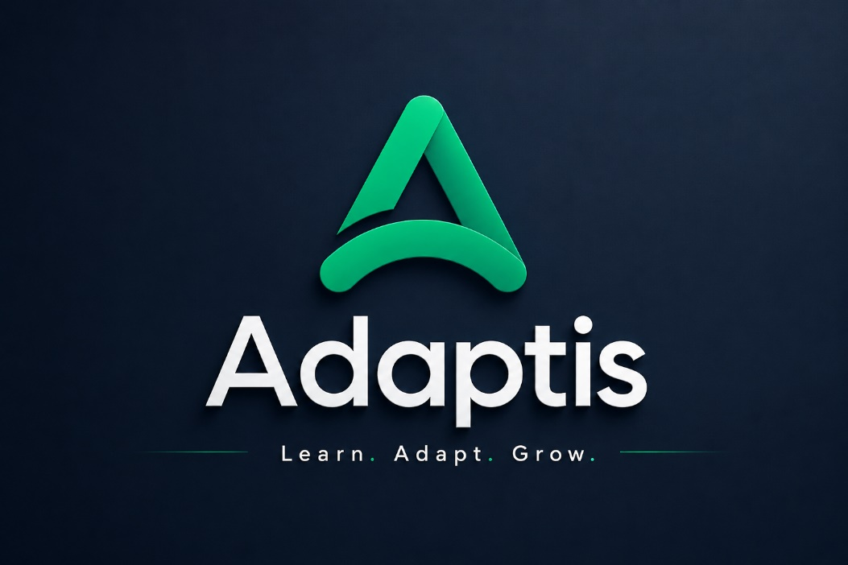

2.1 Logo Architecture and Tagline
Our official logo uses a clean, modern, and simple look built around a custom-curved green letter "A". The bottom legs of the letter are shaped to look like an upward-moving arch or an arrow. This design represents moving forward, educational progress, and adapting to tough situations. Right next to this icon, the name of the brand is written in a dark, clean, geometric font that looks stable, reliable, and trustworthy. Tucked neatly underneath the name is our official project tagline: Learn. Adapt. Grow.

2.2 Application Launcher Icons
To ensure our application icon looks crisp and clean on all different types of smartphones, home screens, and operating system updates, we created three specific app icon tiles:

2.2.1 Primary Brand Variant
- This icon is a solid green square tile with a white letter "A" sitting right in the center. This is the standard icon that will show up on a student’s normal phone home screen app grid.

2.2.2 Minimalist Light Variant
- This icon uses a clean white square background with a green letter "A" in the middle. It is made for users who prefer very clean, simple styles or use bright, light-colored wallpapers on their devices.

2.2.3 High-Contrast Dark Variant
- This icon displays a dark, near-black square tile with a bright green letter "A" inside. This option blends perfectly with a smartphone's native dark mode settings, which helps reduce eye strain when students study late at night and saves battery life on basic mobile phones. The logo is shown below:
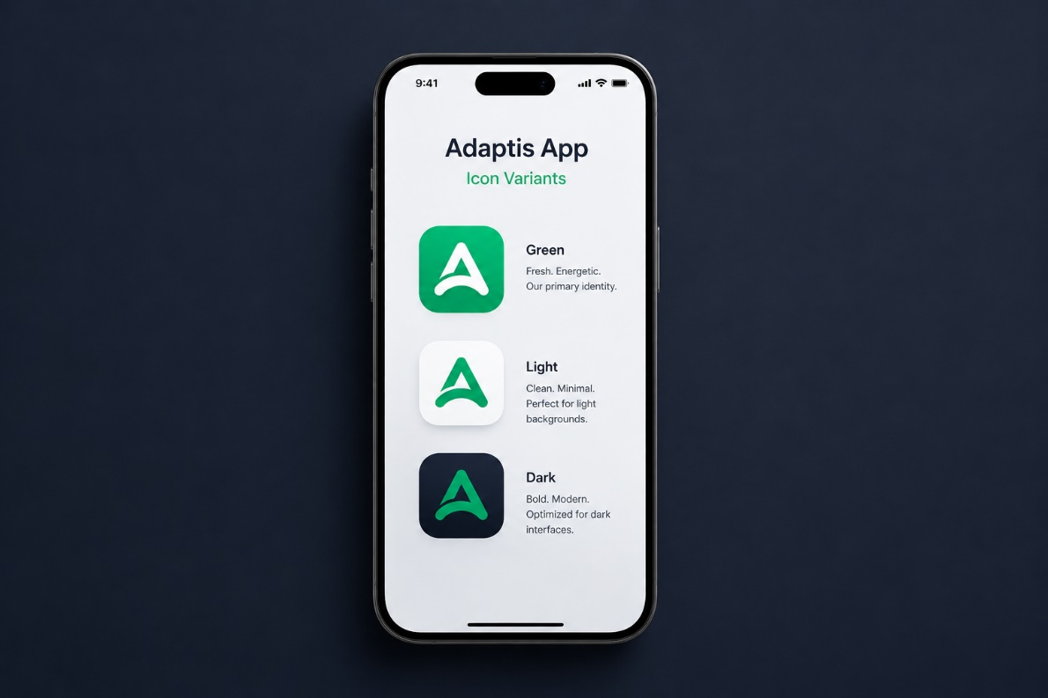

3. Visual Design
The visual design framework prioritizes accessibility and simplicity, ensuring that the app is easy to navigate and does not overwhelm the student. To create this look, our team used Figma as our main design tool. Figma allowed us to draw out layout blueprints (wireframes), test user paths, and perfect our designs collaboratively before writing a single line of frontend code. This approach ensured that every page fits together perfectly and looks great on all screens.

3.1 Typography Hierarchy and Readability
The font choices we made play a massive role in making sure our digital lessons are easy for anyone to read. We selected a highly legible, clean, modern font style to use across all mobile screens and teacher windows. We carefully set the size, thickness (boldness), and spacing for every single piece of text, ensuring that dense lesson descriptions, quiz questions, and notification messages remain incredibly sharp. This keeps reading highly comfortable even on very small mobile displays or low-resolution phone screens common in rural communities.

3.2 Color Palette and Strategic Color Significance
To keep students focused on their lessons and prevent their eyes from getting tired, we used a very disciplined color scheme made up mostly of Green, White, and Black/Deep Gray. Each of these colors was chosen for a very specific reason to improve the user experience:

3.2.1 Green (Action & Progress)
- What it represents: Growth, success, energy, and moving forward in education.
- Why we used it: It is our main brand color. We use it strictly for things that require action—like tap buttons, navigation menus, and the internet status indicators—so students instantly know where to click.

3.2.2 White (Clarity & Focus)
- What it represents: Cleanliness, simplicity, and open space.
- Why we used it: We used white for our page backgrounds and content boxes. Keeping the background clean removes distractions and allows the actual schoolwork and text to stand out right in the center.

3.2.3 Black / Deep Gray (Structure & Comfort)
- What it represents: Authority, stability, and high contrast.
- Why we used it: We used black and dark gray mostly for text and headings. It makes words very sharp and easy to read against the white background. We used a softer deep gray for long paragraphs so that students can read for hours without getting eye strain or headaches.

3.3 Layout Structure and Navigation Flow
The physical setup of the app makes sure that the actual schoolwork stays the absolute center of attention on every single page. The screen features a fixed navigation bar at the top for quick, main options, combined with a clean sidebar menu that slides out to show the student's courses, lessons, and profile settings. Information is organized neatly inside clean, border-free boxes (cards) to group matching topics together naturally. By purposely avoiding heavy decorative artwork, confusing color gradients, and thick shadows, the entire interface stays incredibly lightweight. This design allows pages to open instantly and respond immediately the moment a user taps the screen.
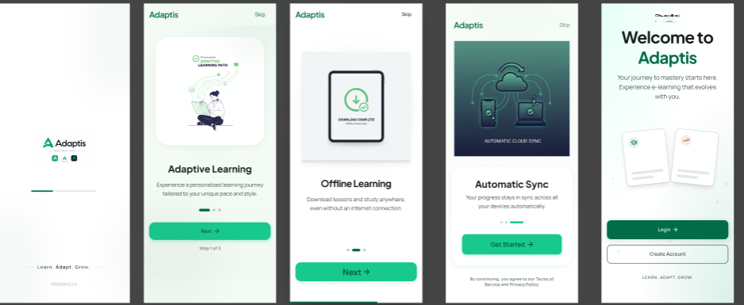
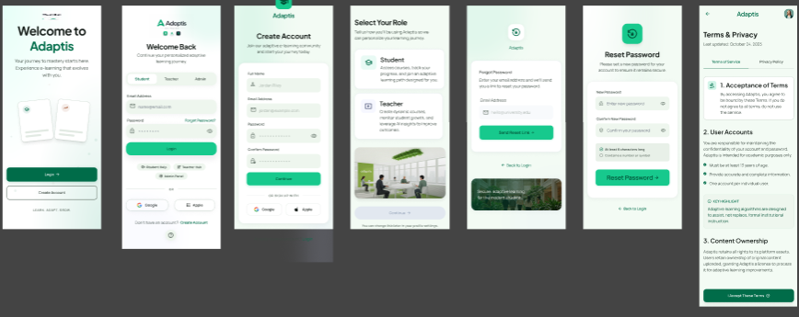
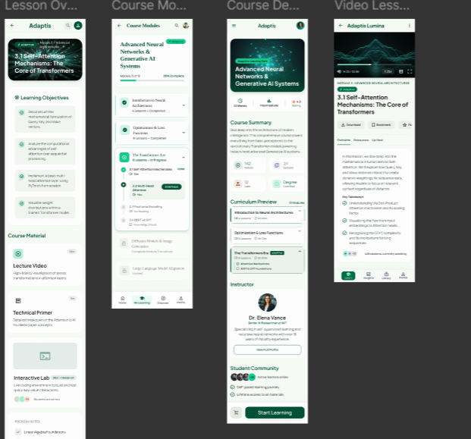
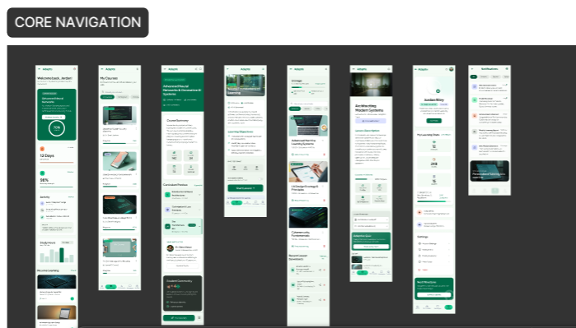
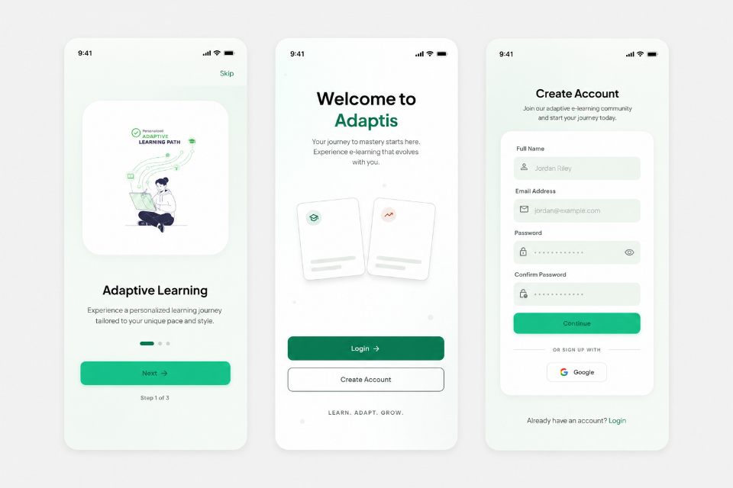

4. Frontend Implementation

4.1 Demo System Goals and Constraints
For our current project presentation milestone, our team built the frontend as an isolated, frontend-only demo application system. This means that while all the buttons, page transitions, sliding menus, and navigation links work perfectly when you tap them during a presentation, the app pulls information from built-in sample files (mock data) rather than connecting to live backend servers, external cloud databases, or actual video-streaming platforms. This smart design choice allows us to showcase the entire user experience and demonstrate exactly how fast the app responds right during our class presentation without needing to rely on a live internet connection.

4.2 Student Mobile Interface

4.2.1 Technology Stack Selection
- The mobile app was built using the Flutter cross-platform SDK and Dart programming language. This framework allowed us to write one single set of code that compiles natively for smartphones, ensuring smooth layout transitions and fluid animations even on low-end and mid-range Android devices used by many local students.
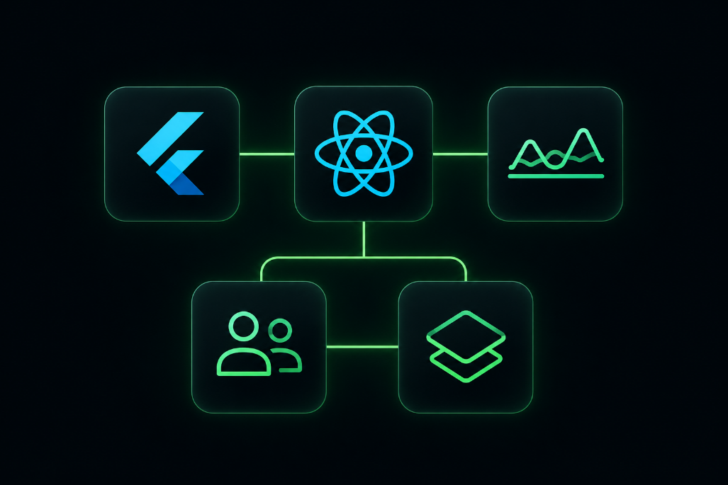

4.2.2 Implemented Mobile Views
- We built out all the essential screens needed for a full walk-through: this includes the splash screen animation, onboarding sliders, login and sign-up forms, the main student home dashboard, course catalogs, lesson lists, the media content playback window, quiz pages, the offline download library, and student progress sheets.
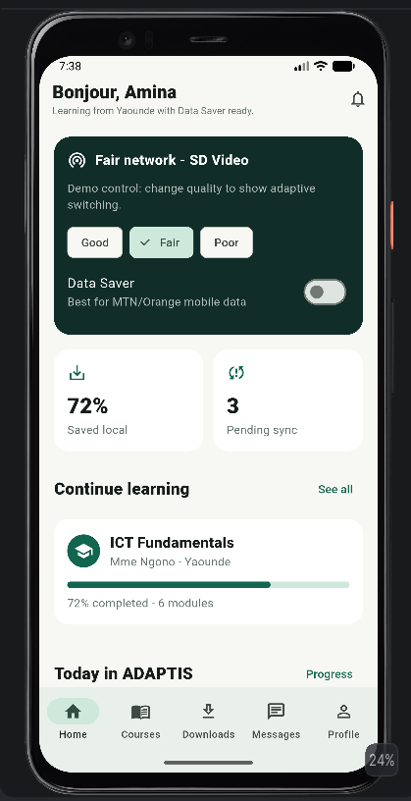
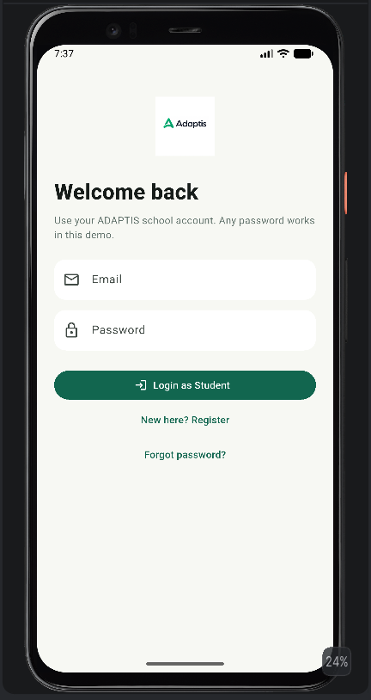
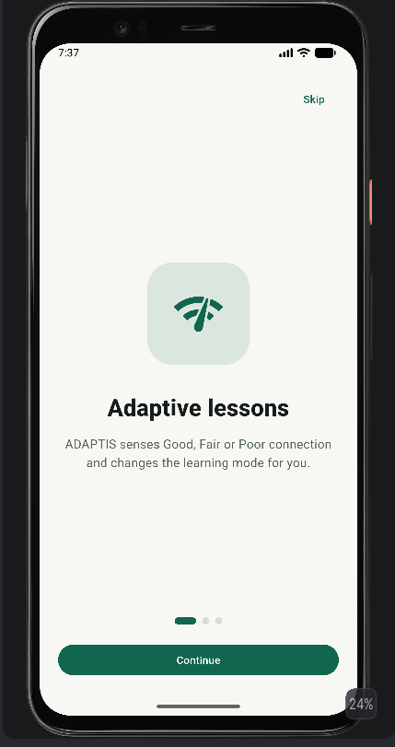

4.2.3 Network Quality Simulation (QoE)
- To show exactly how our adaptive network features work in real life, we built a special simulation controller inside the mobile app that lets users manually switch between three different internet speeds during the demo:
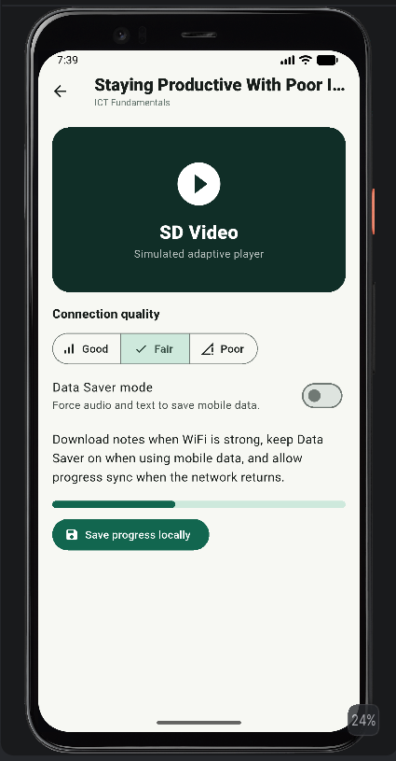
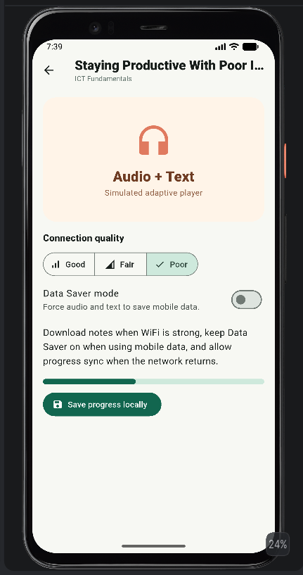
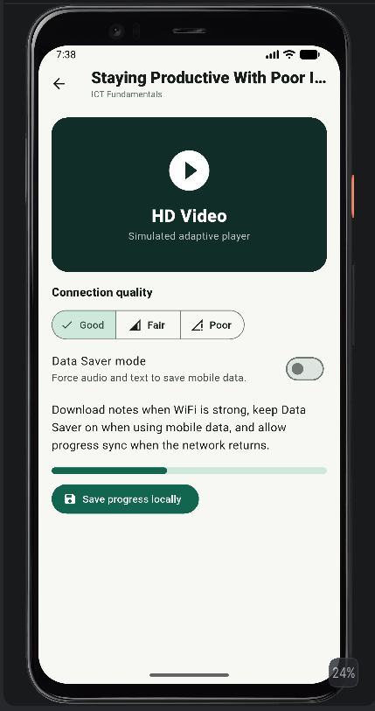
  - Good Network: The app automatically detects a strong connection and streams high-definition (HD) lecture videos.
  - Fair Network: The app drops down to play standard-definition (SD) videos to save internet data and prevent annoying loading pauses.
  - Poor Network: The app instantly activates a fallback mode that completely hides the video player and switches to an ultra-lightweight Audio track paired with text summaries, allowing the student to keep learning without a single freeze.
  - Data Saver Switch: We added a manual button that lets students force the app into text-and-audio mode instantly, allowing them to save their personal mobile data bundles on purpose.

4.2.4 Local Storage and Visual Assets
- Local Data Saving: The mobile app integrates SharedPreferences to save small pieces of information directly on the phone’s built-in memory. This saves the student’s daily lesson progress locally and sets up the foundation needed to handle full offline lesson downloads and quiz submissions later when there is no internet at all.
- Clean Icons: The app utilizes standard Material Design Icons natively supported by Flutter. These clean icons make folders, downloads, messages, and settings profiles instantly easy to recognize for users of all technical backgrounds.

4.3 Teacher and Admin Web Dashboard

4.3.1 Web Technology Framework
- The main web dashboard for teachers and admins was created as a fast single-page app using React and Vite. React’s component structure is perfect for building data-heavy screens and tables, while Vite acts as a lightweight engine that guarantees the web page launches instantly during local testing.
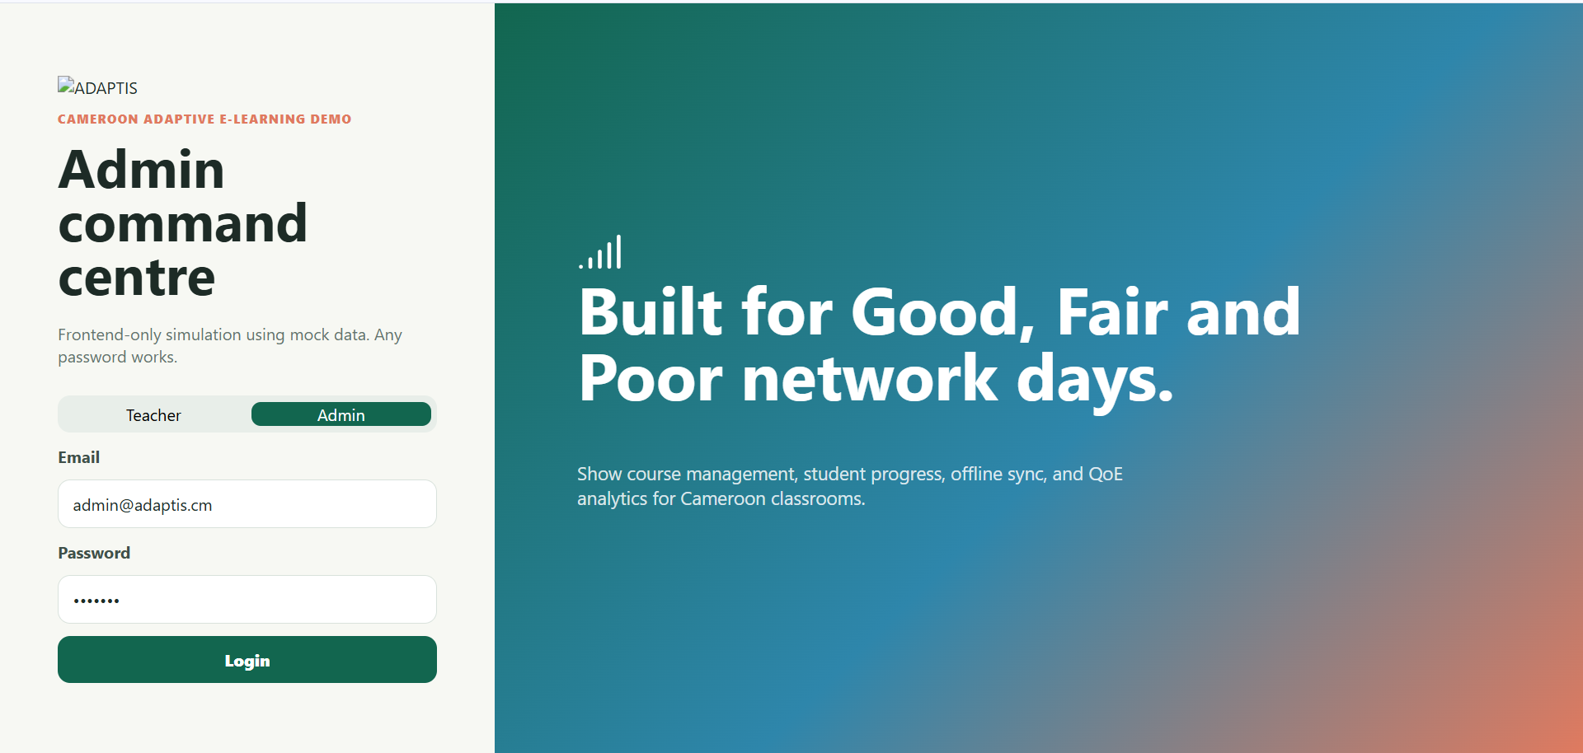

4.3.2 Teacher Viewspaces and Module Tools
- The teacher portal gives instructors access to clean tables for creating and managing academic course layouts, arranging lesson lists, designing multiple-choice quizzes, and checking student grading sheets. The lesson creation page features a mock upload area that shows exactly how video files will be split up automatically into multiple adaptive formats (720p, 360p, audio tracks, and text notes) behind the scenes.
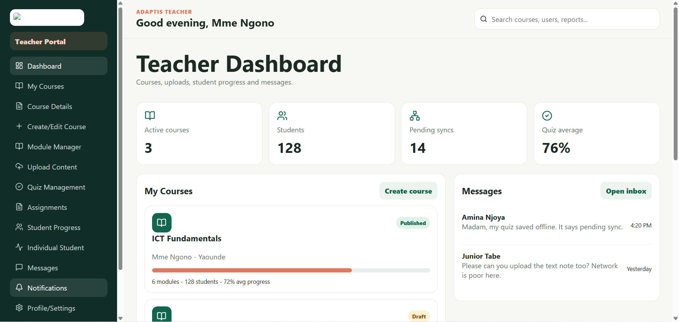

4.3.3 Admin Viewspaces and Analytics Integrations
- System administrators get a separate, high-level control screen designed to watch over the overall health of the entire platform. This layout allows admins to review user accounts, monitor active course listings, check system security, and audit platform performance data.
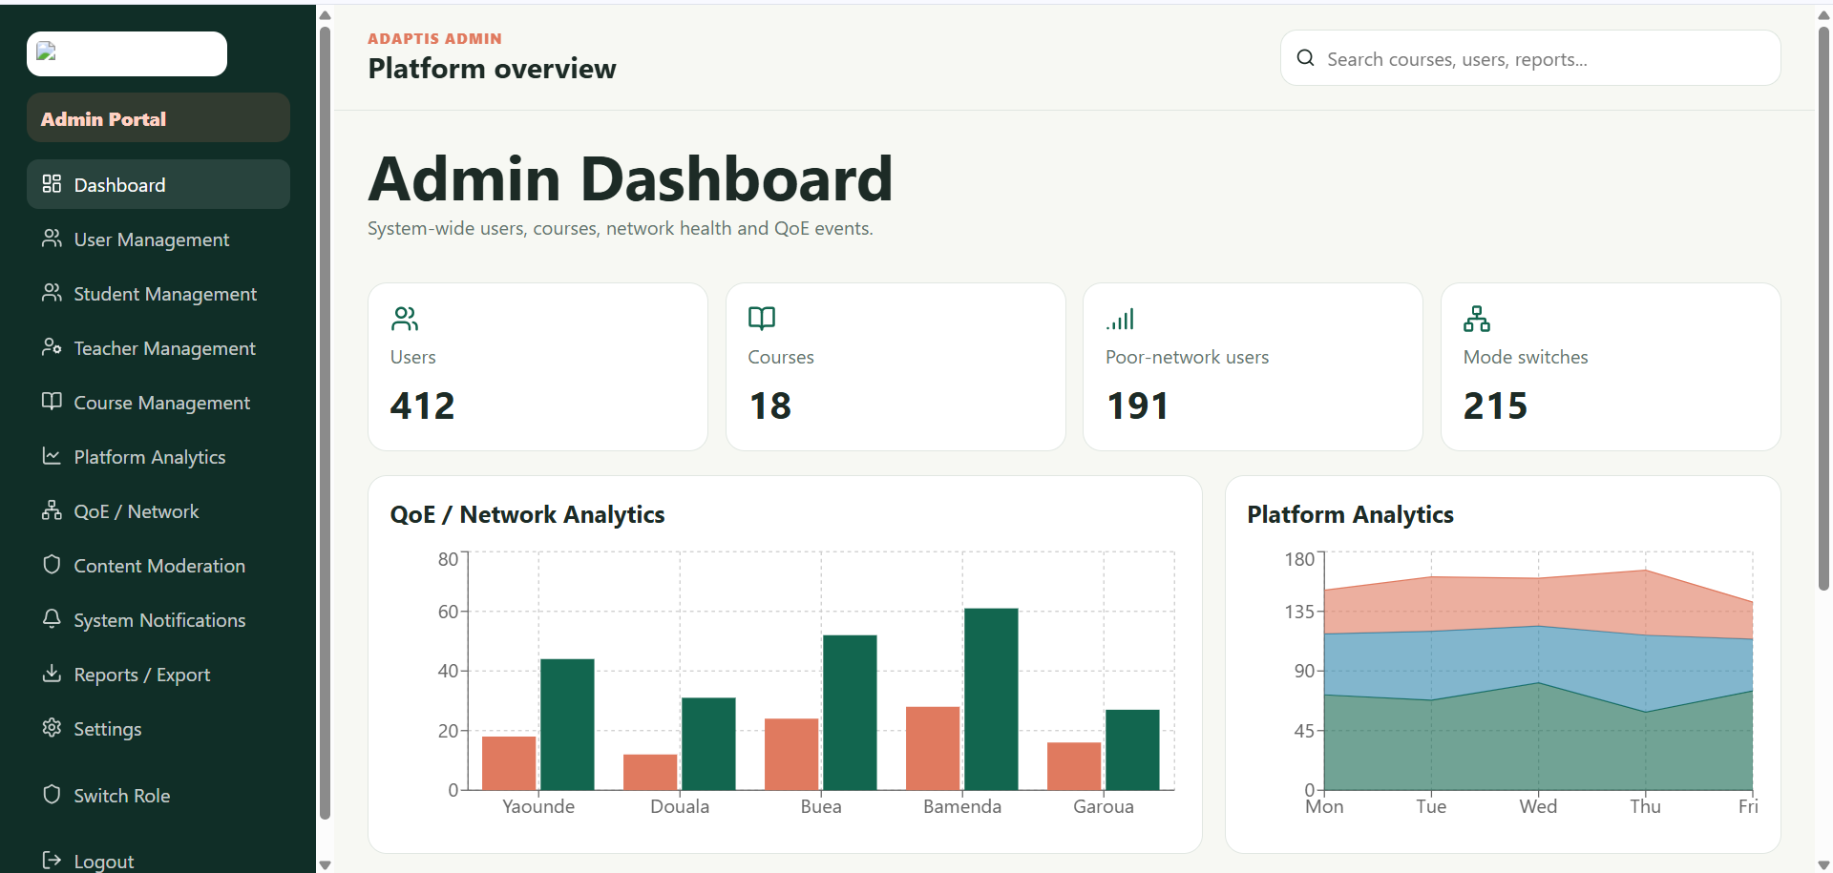

4.3.4 Visual Charts and Local Cameroonian Context
- Dynamic Charts: We integrated a tool called Recharts to turn our sample data into clear, moving graphs on the admin dashboard. These graphs show critical evaluation metrics, such as how many students are currently forced into Audio + Text mode, video buffering frequencies, and network connection distributions sorted by local Cameroonian cities like Yaoundé, Douala, Buea, and Bamenda.
- Local Focus and Styling: The web interfaces are styled using organized, custom CSS sheets and clean Lucide React vector icons. To make the software demo feel highly realistic and relevant to our target audience, all student names, class records, and cellular carrier scenarios were tailored to match local environments (like tracking data usage over networks like MTN and Orange).

4.4 Architecture Framework Directory
The entire project folder is neatly split up into four main directories to keep the code perfectly organized:
- student_mobile/ : Contains the complete Flutter and Dart mobile application source files, state managers, and screen views.
- adaptis_web/ : Houses the React and Vite web dashboard source directories, administrative chart code, and web page layouts.
- shared_assets/ : A centralized folder that holds our unified brand logos, official colors, and vector icon sheets.
- scripts/ : Contains cross-platform terminal commands to help compile, launch, and run both applications easily.

5. Conclusion
In conclusion, this frontend phase has successfully delivered a fully interactive visual prototype of our adaptive learning solution. By building a mobile app in Flutter and responsive web dashboards in React based on our initial Figma designs, we have proven exactly how students, teachers, and admins will interact with the system. This project successfully proves our core thesis: we can stop weak internet from blocking education by automatically scaling media down into a deliberate, clean layout built on Green, White, and Black/Deep Gray audio and text formats. With the user interfaces fully finalized and customized for our local context, our project is now in an excellent position to move into the next phase, which will involve building live backend servers and connecting database networks. The next Steps Include the Backend Implementation.

Link to Figma File: https://www.figma.com/design/DD0b1EErJ2bw9yeyiBIVFf/ADAPTIS-UI-SCREENS?node-id=1-2&t=BPPvx94mXzbtlOyq-1

